There is a long table with a line of plates and candles arranged on top of it. You are given a **0-indexed** string s consisting of characters '*' and '|' only, where a '*' represents a **plate** and a '|' represents a **candle**.

You are also given a **0-indexed** 2D integer array queries where queries[i] = [lefti, righti] denotes the **substring** s[lefti...righti] (**inclusive**). For each query, you need to find the **number** of plates **between candles** that are **in the substring**. A plate is considered **between candles** if there is at least one candle to its left **and** at least one candle to its right **in the substring**.

* For example, s = "||**||**|*", and a query [3, 8] denotes the substring "*||**\*\***|". The number of plates between candles in this substring is 2, as each of the two plates has at least one candle **in the substring** to its left **and** right.

Return *an integer array* answer *where* answer[i] *is the answer to the* ith *query*.

**Example 1:**

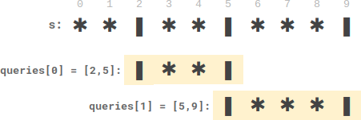

**Input:** s = "**|**|***|", queries = [[2,5],[5,9]]

**Output:** [2,3]

**Explanation:**

- queries[0] has two plates between candles.

- queries[1] has three plates between candles.

**Example 2:**

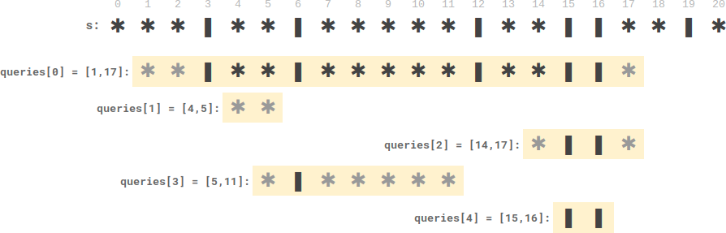

**Input:** s = "***|**|*****|**||**|*", queries = [[1,17],[4,5],[14,17],[5,11],[15,16]]

**Output:** [9,0,0,0,0]

**Explanation:**

- queries[0] has nine plates between candles.

- The other queries have zero plates between candles.

**Constraints:**

* 3 <= s.length <= 105
* s consists of '*' and '|' characters.
* 1 <= queries.length <= 105
* queries[i].length == 2
* 0 <= lefti <= righti < s.length